Aug 1 2025 BDBP106: Linux and Python programming Lab 5
Ankita Bose, PhD
1. EXERCISES Start a fresh terminal for this Lab.
(1) Look for the pattern ‘Meningoma’ in the data file. Redirect the output to a new file
called ’LinesWithMeningoma.out’. Show the command used and the contents of this
new file in your screenshot
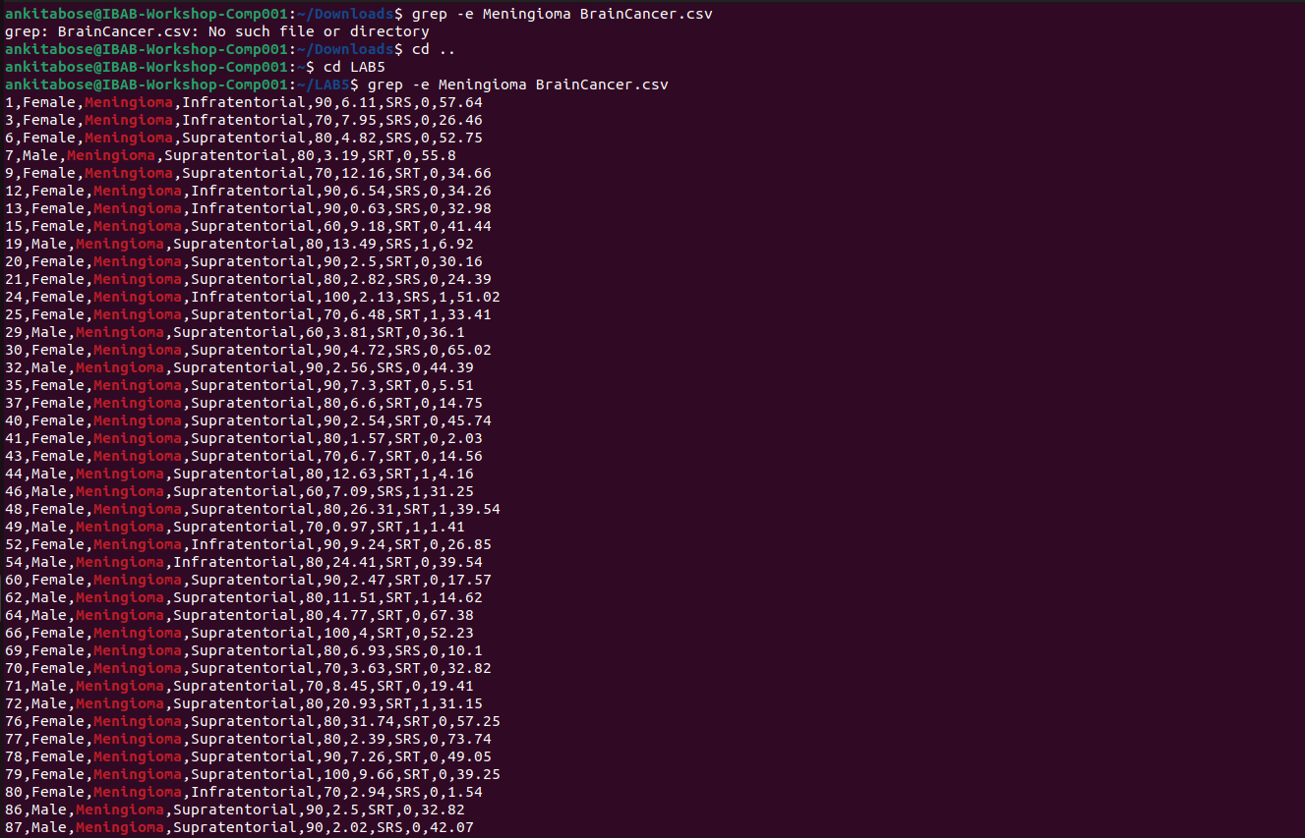
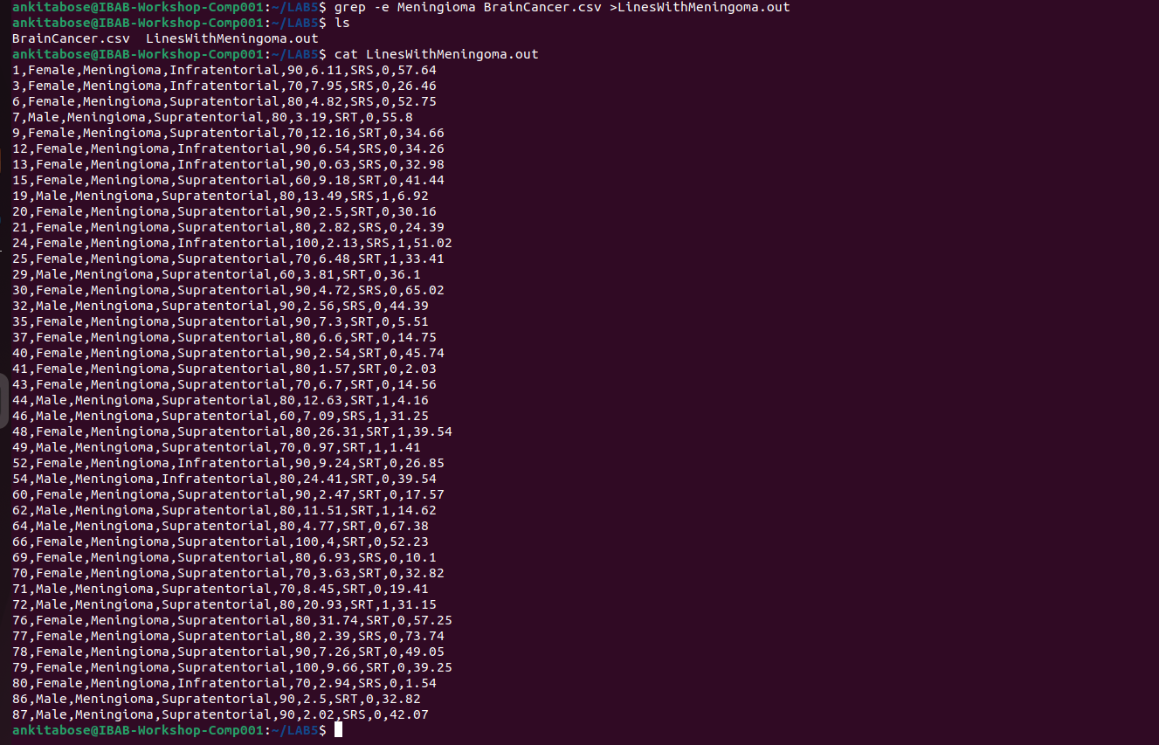
2) How many males and females were present in this study? How will you create a grep
filter to find this out?

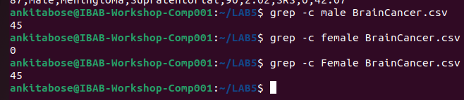
(3) How many males have supratentorial brain cancer and how many females have infraten-
torial cancer? Which option in grep makes you ignore the case while searching? Make
use of this in this exercise.
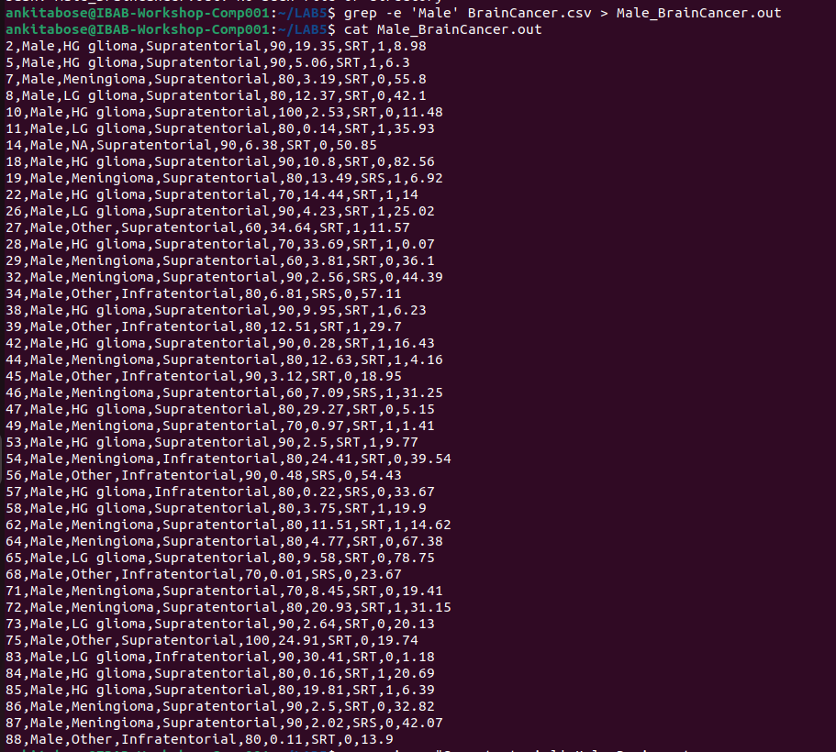
-
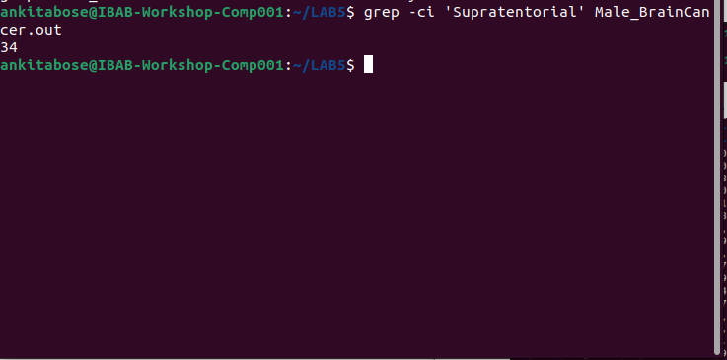
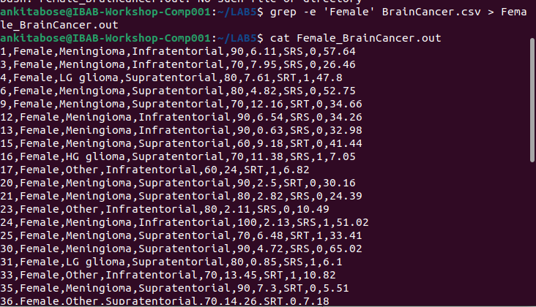

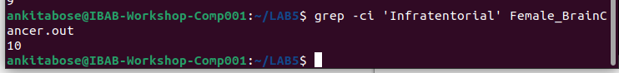

4) Find which patient has the lowest ki value. (Hint: Use sort for this, it’s easier)
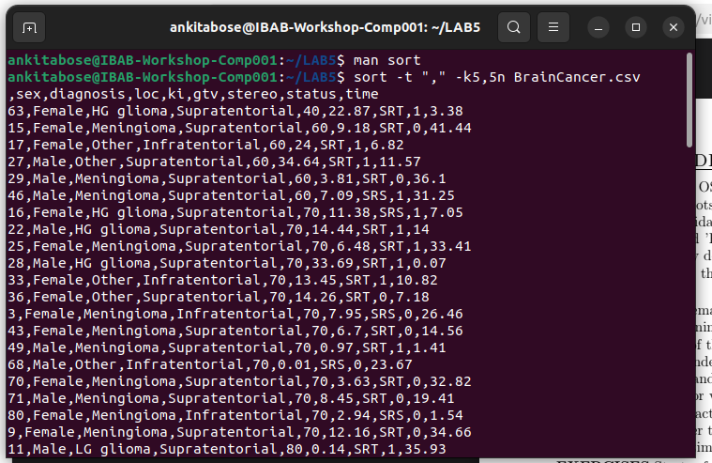
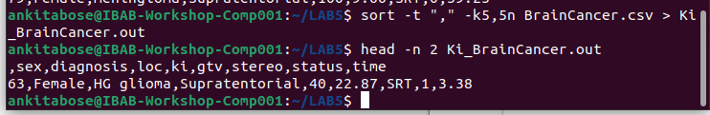
5) Print the output by searching for the patterns ’SRS’ as well as ’infratentorial’. How
many such entries are there?

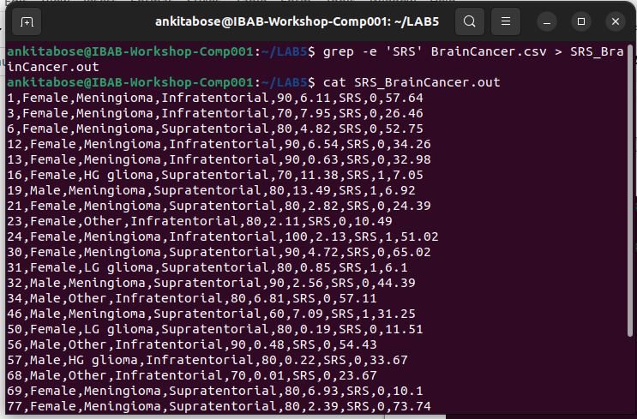
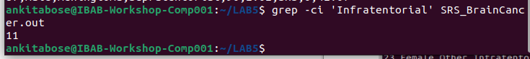
(6) List the patients who have survival times more than 50 months.
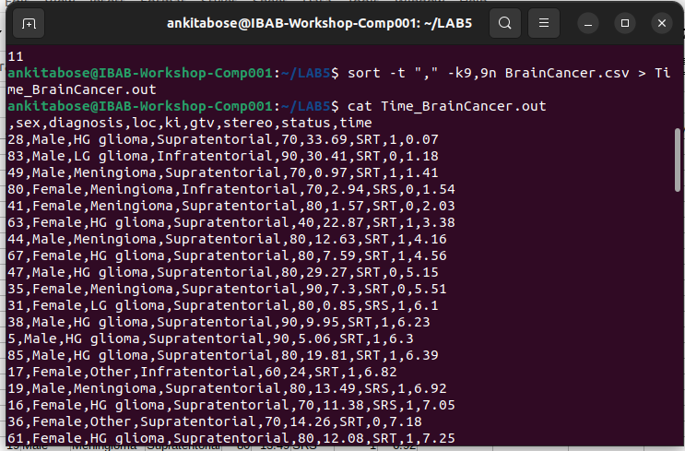

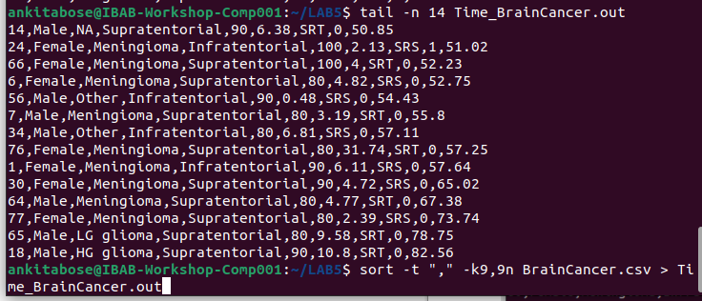
7) List the patients who have HG glioma and have survival times more than 50 months.
How many are there?

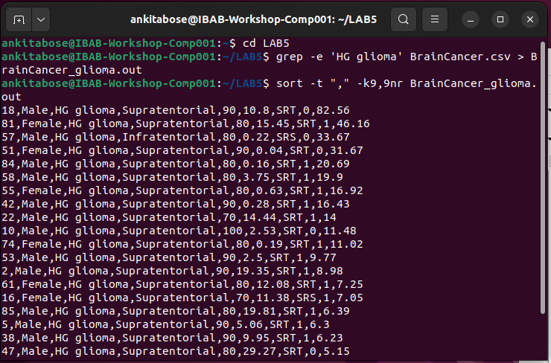

8) List the patients who have LG glioma with location supratentorial and survial times less
than 30 months. How many are there?
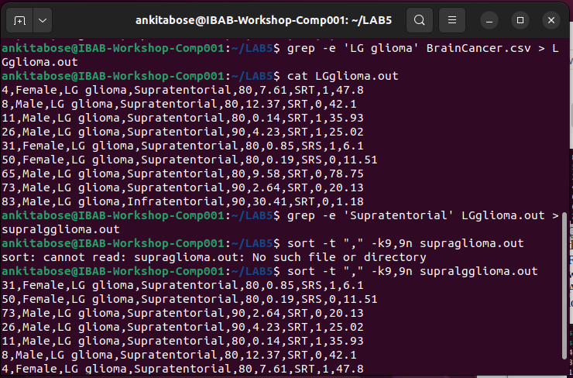
9) By default does grep ignore or not ignore case? Demonstrate this by using the appro-
priate option and by running the grep command without this option.
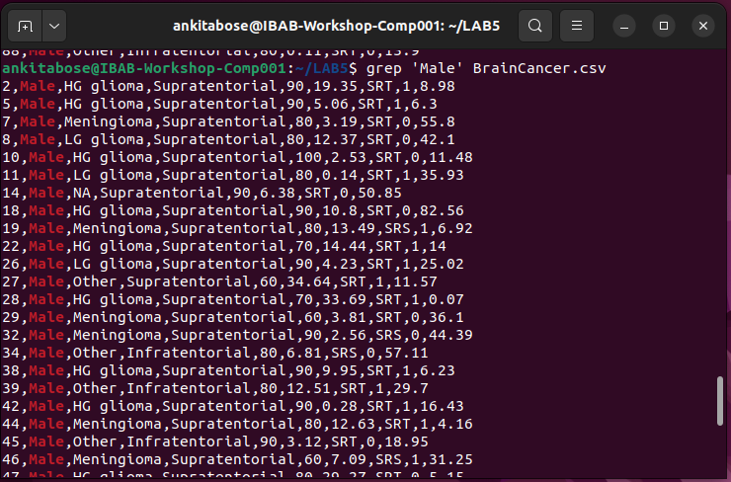

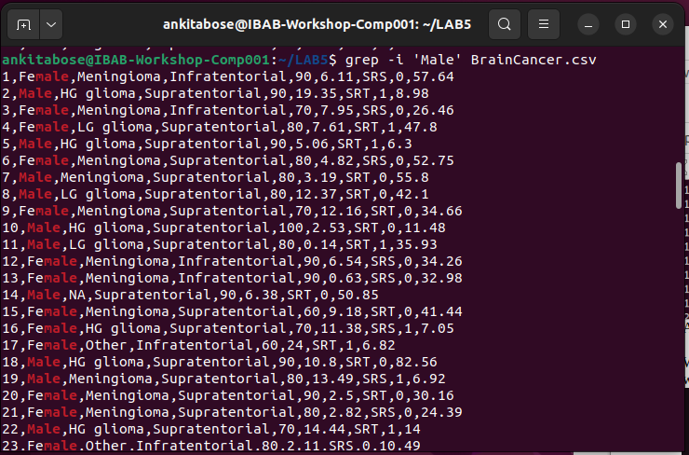
10) List the patients who are dead at the end of the study. How many are there? Find
another way to listing this set of patients
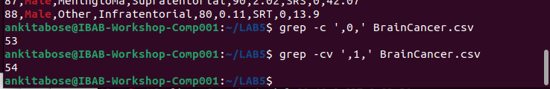
11) Let’s list the patients who have their cancer in infratentorial location. How many are
there? How do I restrict the output to first ten patients?
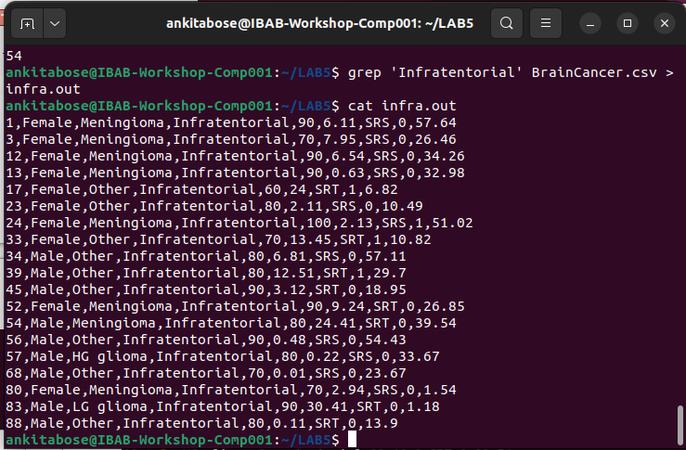

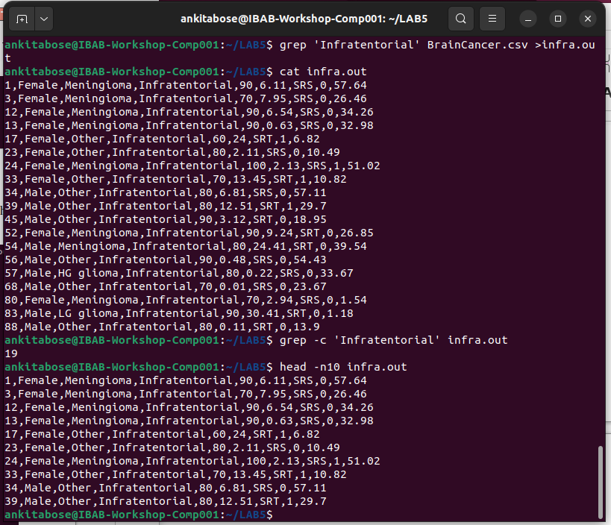
Q12. Create an archive file by combining the outputs of questions 1-5.
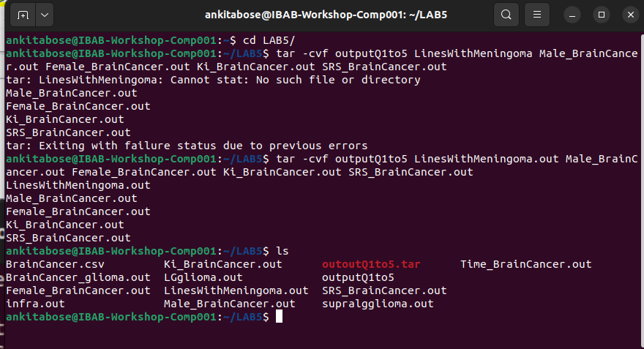
By using tar cvf we can create a new archive file and v stands for verbose, meaning it will list the files that are added and f for using the archive file.
Q13. Create a zipped and archived file by combining the outputs of questions 6-11.

For zipping we need to give the command tar -z and .tar and .zip in the new file name that is created.
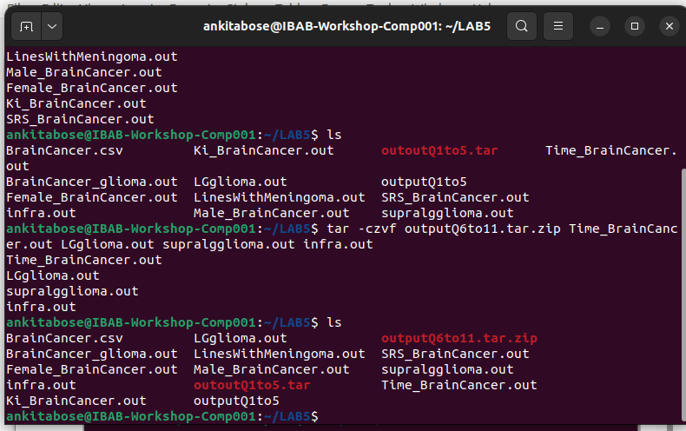
Q14. List and extract the contents of the archive file created in (12) to a new directory and list the contents of the new directory.
To extract the contents to a new directory, we use -C command.
Tar -xvf means, we are extracting the files which are already archived and keeping them in a new directory. For this – C command is used, to change to specified directory before extraction.

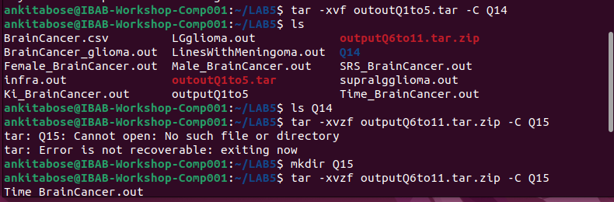

15. List and extract the contents of the archived-zipped file in (13) to a new directory and list the contents of the new directory.
We use tar -xvzf for extracting and decompressing the zip file.

